| | Sección 1. Información General   | **Curso** | Taller de Proyectos 1 | **Unidad Académica** | Sistemas EPE | | --- | --- | --- | --- | | **Sprint** | 3 | **Semana** | 1 | | **Fecha** | 20/12/2021 – 23/12/2021 | **Lugar** | Virtual | | **Hora Inicio** | - | **Hora Fin** | - | |  |  |  |  | | | --- | --- | --- | --- | --- | --- | --- | --- | --- | --- | --- | --- | --- | --- | --- | --- | --- | --- | --- | --- | --- | |
| --- | --- | --- | --- | --- | --- | --- | --- | --- | --- | --- | --- | --- | --- | --- | --- | --- | --- | --- | --- | --- | --- |

Sección 2. Participantes

| **Participantes** | **Rol** | **Día 1** | **Día 2** | **Día 3** | **Día 4** | **Día 5** |
| --- | --- | --- | --- | --- | --- | --- |
| **DD/MM** | **DD/MM** | **DD/MM** | **DD/MM** | **DD/MM** |
| Edwin Espinoza | Jefe de Proyecto | Si | Si | Si | Si | Si |
| Cesar Suarez | Desarrollador Frontend | No | No | No | Si | Si |
| Luis Pareja | Desarrollador Backend | Si | No | Si | Si | Si |
| Nicolas Masias | Desarrollador Backend | Si | Si | Si | Si | Si |

Sección 3. Evidencias

· Documentar con fotos o videos las ceremonias y artefactos correspondientes a cada día del sprint mostrando fecha y hora.

· Indicar el nombre de la ceremonia por cada día.

Día 18-21: https://drive.google.com/drive/folders/10hEMqrh8N3N-pOZkyLCHgb-zsnUrI8hl?usp=sharing

| | Sección 1. Información General   | **Curso** | Taller de Proyectos 1 | **Unidad Académica** | Sistemas EPE | | --- | --- | --- | --- | | **Sprint** | 3 | **Semana** | 2 | | **Fecha** | 20/12/2021 – 23/12/2021 | **Lugar** | Virtual | | **Hora Inicio** | - | **Hora Fin** | - | |  |  |  |  | | | --- | --- | --- | --- | --- | --- | --- | --- | --- | --- | --- | --- | --- | --- | --- | --- | --- | --- | --- | --- | --- | |
| --- | --- | --- | --- | --- | --- | --- | --- | --- | --- | --- | --- | --- | --- | --- | --- | --- | --- | --- | --- | --- | --- |

Sección 2. Participantes

| **Participantes** | **Rol** | **Día 1** | **Día 2** | **Día 3** | **Día 4** | **Día 5** |
| --- | --- | --- | --- | --- | --- | --- |
| **DD/MM** | **DD/MM** | **DD/MM** | **DD/MM** | **DD/MM** |
| Edwin Espinoza | Jefe de Proyecto | Si | Si | Si | Si | Si |
| Cesar Suarez | Desarrollador Frontend | No | No | No | No | No |
| Luis Pareja | Desarrollador Backend | Si | Si | Si | No | No |
| Nicolas Masias | Desarrollador Backend | No | No | No | No | No |

Sección 3. Evidencias

· Documentar con fotos o videos las ceremonias y artefactos correspondientes a cada día del sprint mostrando fecha y hora.

· Indicar el nombre de la ceremonia por cada día.

Lunes:

Edwin:

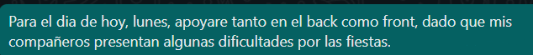

Luis:



Martes:

Edwin:

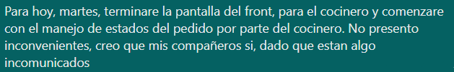

Luis:

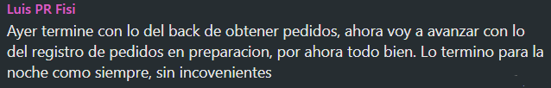

Miércoles

Edwin:



Luis:

